Seasonality of Marriages and Marriage Age in Bangladesh

Evidence in DHS: 1956-1977

ABSTRACT

When doing a time series analysis on the count of marriages and the mean of female marriage for each month in the DHS Individual data set, we observe a distinguishable seasonality that is consistent throughout the years. This internal report covers the decomposition of mean marriage age and marriage count, and centers on a theory of seasonal effects on marriage. This paper finds that the rate of marriage increases during post-Aman rice harvest periods and falls in times of seasonal poverty (*monga*) where the marriage age decreases in post-harvest and increases in the *monga*. This paper offers insight into why this relationship occurs and how incomes and bride price relate to such phenomena. Lastly, I review the papers in the Dropbox Literature folder that mention seasonality and relate them to these findings. Ultimately, a stylized fact of seasonality is established and is essential to offering insight on early female marriage in Bangladesh at the demographic level.

INTRODUCTION

Mean marriage age is calculated as the mean of female age at time of birth by century month. Where each century month has one value- the mean marriage age. The marriage count (or rate) sums the number of marriages within a given century month. The mean marriage is sample weighted where the marriage count is not (it is simply the number of marriages in a century month according to the sample so it is unweighted). There were not large differences in the mean marriage age unweighted and weighted datasets and seasonality was not affected at all. I assume that is the case for the marriage count as well.

Figures 1 and 2 show the time series decompositions where the data, trend, seasonal, and remainder elements are separated from the data.

Figure 1

Figure 2

There are clear trends and seasonality in both mean marriage age and the marriage rate[1]. Note that there is a rising trend for both mean marriage and the marriage rate with deviations from a linear trend. Also note the clear seasonality in both decompositions- they are both pronounced and unwaver throughout the years.

The focus on this paper is on the seasonality of these two observations. But one thing to note is that the remainder will be the focus of the war and famine shocks since these are the marriages that are not determined by seasonality or the trend.

IMPORTANCE OF SEASONALITY

Seasonality is a significant element of Bangladesh society and is therefore essential to understand in terms of studying events such as the 1971 war and famines. It is significant because much of the income and output created in Bangladesh during this time came from agricultural goods. Therefore, we would expect a seasonal relationship with mean marriage age and the number of marriages with crop harvest.

There are three main harvests in Bangladesh[2]:

Aman Rice: November-December (largest crop in Bangladesh agriculture: ½ of all rice crops)

Boro rice: May-June

Aus rice: May-June

Harvests can be characterized as events of high labour demand and post-harvest can be characterized as events of relatively high incomes- both compared to the rest of the year. Pitt and Khandker elaborate on this stating:

“The Aman harvest during the months of November-December is characterized by the greatest demand for agricultural labor. The labor demand is also relatively high in the months of January and March, when the transplantation of Boro HYV takes place. Labor demand is lowest during the months of September-October just before the harvest of Aman rice. This seasonality in labor demand is mirrored by the seasonal pattern of agricultural employment and wages, and consequently, in the seasonal consumption landless households who depend heavily on wage employment.” (Idib, page 16)

They also find gendered differences in demand for labour according to each harvest where “women’s Aman season labor supply is about 25 percent higher than Boro and Aus season labor supply. Men’s labor supply is highest in the Aman season, 5 percent lower in the Boro season, and 8 percent lower than in the Aus season” (Idib, page 17). Reflecting on our data and given the pronouncement of female labour during the Aman harvest, November- December would be a time that we would see less marriages. It is unclear what we would expect for the mean marriage age but the data shows that there is an increase in the mean marriage age (further work should explain why this is the case).

Not only is there social significance surrounding the harvest, but there is also a period before the harvest – the *monga* – where seasonal poverty is at its peak. These months are from September-December. Khandker (April 2009)[3] writes on the seasonality of Bangladesh incomes and highlights the Monga period (period studied: 2000-2005).

Figure 3

Figure 3 (from Khandker) illustrates that total income drops below total consumption in the rest of the country outside of Rangpur (which is not a Division sampled in DHS data) during the *monga* in September- November. This drop observed during these years suggests consumption smoothing where households save during the good times and spend the savings during the bad times. However, Khandker (April 2009) does not find such evidence. He states:

“Econometric analysis confirms that the perfect consumption smoothing model is rejected and that seasonal variations in income substantially track seasonal consumption and poverty. Lack of income smoothing is therefore a major factor causing seasonal food deprivation in Rangpur. Households likely resorted to traditional means (e.g., self-insurance, interfamily transfers, or borrowing from informal sources) to cope with extreme volatility or shortfalls in consumption. But these traditional methods are certainly inadequate; otherwise, the incidence of *monga* would not have occurred every other year, especially in Rangpur in such a scale.” (page 35)

The rejection of perfect consumption smoothing and this resorting to traditional means to survive the *monga* takes the marriage analysis on an interesting turn. If the mean marriage age is higher than average, and the rate of marriage is lower, it would suggest that those who are older and dependent on agriculture would find it economically beneficial to marry. Where during the post-harvest period (the rate of marriage is high and the mean marriage age is younger) a daughter’s bride price is lower relative to being married during *monga*- given that families must pay a dowry for their daughter to be wed. This suggests that the absence of perfect consumption smoothing may lead to marriages being used as a means to relieve financial burden in the *monga*.

Before looking at the literature, let’s look at the data while keeping this understanding of seasonality in mind.

MEAN MARRIAGE SEASONALITY:

For all first marriages of Bangladeshi women, the seasonality of mean marriage age does not change across years. This helps us in understanding the dynamics of marriage age with the rest of seasonal elements in society. What we observe is a negative seasonal effect on marriages from January to July and a positive effect from September to December. The largest effect, and jump from its previous month, is in September where the mean marriage age increases from -0.1 to 0.3 years, approximately.

Figure

Overall, this suggests that women are getting married younger in the first half of the year and older in the second half (by about 0.2 years on each end).

If we break this up by urban and rural women, we see a clearer picture:

Figure 5

Figure 6 note y-axis scale compared to urban

First, note that Figure 6 is similar to Figure 4 in terms of the shape. This is because most of the sample, and population, are rural. In Figure 5 is urban married women. What we see is some months are positive, others are negative. The drop in marriage age of -0.5 years in March is stark and is worth investigating further. But from May there are dips and rises that sum to close to zero.

RATE OF MARRIAGE

Figure 7

The seasonality of the marriage rate is clear and contrasts with that of the mean marriage age. Here the marriage rate is at its highest in February and declines to 0 by July, with the second half of the year reducing the number marriages. The most negative seasonal effect on the marriage rate is in the *monga­* period from August to October which is also when the mean marriage age is the highest.

The decline in the marriage rate is synonymous with total incomes illustrated in Figure 3. Clearly incomes affect the amount of marriages in a given season.

Looking at the urban-rural divide:

Figure 9 note y-axis scale compared to urban

Figure 8

Clearly there is not much of a distinguishing element in the urban seasonality of the marriage rate. However, Figure 9 shows a strong seasonality favoring the post Aman harvest as a time to get married and the *monga* as non-optimal time to get married.

FURTHER ANALYSIS

There are three papers that mention seasonality in the Dropbox Literature folder. These are Corno Hildebrandt and Voena (CHV) (2019), Curlin et al (1976), and Menkin and Phillips (1990). The first is one marriage age and weather shocks in India and SSA, the second is on the impact of the war on births and deaths, and the third is on how family planning in Matlab changed the population of the area in 1967-1987.

India dowry -> drought shock -> reduces hazard of early marriage ->

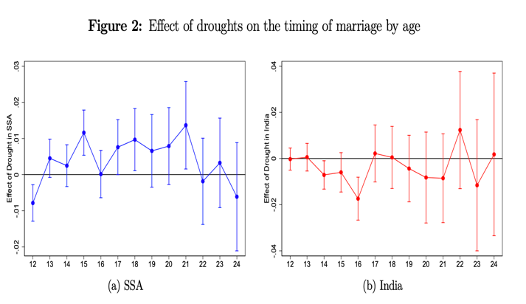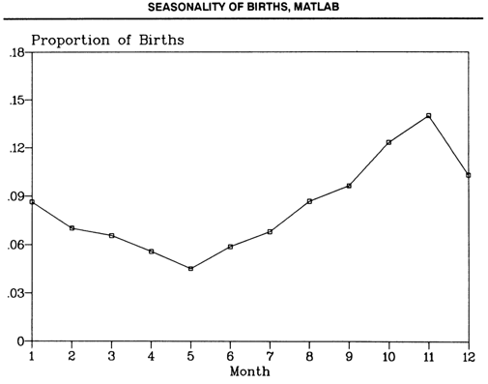

References and Notes

Khandker (April 2009)

<https://openknowledge.worldbank.org/bitstream/handle/10986/4114/WPS4923.pdf?sequence=1&isAllowed=y>

Seasonal poverty in Bangladesh, locally known as monga, refers to seasonal deprivation of food during the preharvest season of Aman rice. An analysis of household income and expenditure survey data shows that average household income and consumption are much lower during monga season than in other seasons, and that seasonal income greatly influences seasonal consumption

The analysis shows that agricultural income diversification accompanied by better access to microcredit, irrigation, education, electrification, social safety net programs, and dynamic labor markets has helped reduce seasonality in income and poverty in regions other than Rangpur in the recent past

Pitt, Khandker 2001

<https://www.brown.edu/research/projects/pitt/sites/brown.edu.research.projects.pitt/files/uploads/seasonality_%20paper_11-26-01_0.pdf>

The survey was carried out in three rounds 16 corresponding to the Aus, Aman and Boro cropping seasons. The first round of the survey was conducted during the months of December/January, during the post-harvest of Aman rice. The second round of survey was carried out during the months of April/May to cover the post-harvest season of Boro rice. The third round of the survey was carried out during the months of July/August to cover the post-harvest of Aus rice

November-December– Aman Rice (harvest) largest crop in Bangladesh agriculture

May-June– Boro rice (harvest)

May-June- Aus rice (harvest)

There are six partly overlapping seasons delineated in the Bangla calendar and three major rice-based seasons are prominent

Becker’s Marriage Model:

<https://www.nber.org/system/files/chapters/c2970/c2970.pdf>

1. I call this the marriage rate as it is simply the number of marriages had in a given century month
2. Pitt, Khandker 2001. Credit Programs for the Poor and Seasonality in Rural Bangladesh. <https://www.brown.edu/research/projects/pitt/sites/brown.edu.research.projects.pitt/files/uploads/seasonality_%20paper_11-26-01_0.pdf>. Period studied: survey from 1991-1992
3. https://openknowledge.worldbank.org/bitstream/handle/10986/4114/WPS4923.pdf?sequence=1&isAllowed=y